

INFOSYS SPRINGBOARD VIRTUAL INTERNSHIP 6.0

CREDITPATH AI
(Loan Risk Prediction and Decision Support System)

Submitted by
R. Sai Sharshitha Reddy

Project Mentorship
Under the guidance of
Shanmukha Priya
(Infosys Springboard Mentor)

Platform
Infosys Springboard

Year
2026

CONTENT
S. No | Title | Page No.
1 | Abstract | 01
2 | Introduction
2.1 | Background | 02
2.2 | Problem Statement | 02
2.3 | Objectives of the Project | 03
2.4 | Scope of the Project | 03
2.5 | Solution of the Project | 04
3 | System Overview
3.1 | System Architecture | 05-06
3.2 | Workflow Explanation | 06-07
3.3 | Modules Description | 07-08
3.4 | Input and Output Tables | 08-09
4 | Implementation
4.1 | Technologies Used | 10
4.2 | Backend Implementation | 10-13
4.3 | User Recommendation Engine | 14
4.4 | Bank Recommendation Engine | 15
4.5 | Frontend Implementation | 15-16
4.6 | Charts and Visualization | 17-18
4.7 | API Integration Flow | 18
5 | Results | 19-23
6 | Conclusion | 24

1
ABSTRACT
CreditPath AI is an intelligent loan risk prediction and decision-support system designed to assist both borrowers and financial institutions in making accurate and efficient financial decisions. In the modern financial landscape, evaluating the creditworthiness of individuals is a critical task, as incorrect loan approvals can lead to significant financial losses for banks and long-term financial instability for borrowers. This project addresses these challenges by developing an automated system that analyzes key financial parameters and provides reliable predictions along with meaningful recommendations.
The system utilizes essential financial inputs such as income, credit score, loan amount, loan type, and repayment history to assess the overall risk associated with a loan application. Based on these inputs, it classifies users into different risk categories, namely low, medium, and high risk. This classification helps borrowers understand their financial position and take necessary steps to improve their eligibility before applying for loans. In addition, the system generates personalized recommendations and actionable tips that guide users in maintaining financial discipline and improving their credit profile.
From the perspective of financial institutions, the system evaluates borrower profiles and calculates important metrics such as default probability and expected loss. These metrics enable banks to assess the level of risk involved and make informed decisions regarding loan approval, conditional approval, or rejection. The system also provides decision-support insights such as priority levels and follow-up strategies, which enhance the efficiency of risk management.
The backend of the system is implemented using FastAPI, ensuring efficient API-based communication and real-time data processing, while the frontend is developed using React to provide an interactive and user-friendly interface. The system also incorporates data visualization techniques such as pie charts, bar graphs, and semi-circular charts to present results in a clear and understandable manner.
Overall, CreditPath AI demonstrates the effective application of intelligent systems in the financial domain, improving accuracy, efficiency, and transparency in loan risk assessment while providing a scalable solution for real-world applications.

2
INTRODUCTION
2.1 Background
In the modern financial ecosystem, loan systems play a vital role in supporting individuals and businesses by providing access to credit. Banks and financial institutions rely on various financial indicators such as income, credit history, and repayment behavior to evaluate whether a borrower is capable of repaying a loan. This process, known as credit risk assessment, is crucial for maintaining the stability of financial institutions.
One of the major challenges in loan systems is the risk of default, where borrowers fail to repay their loans. Loan defaults can lead to significant financial losses for banks and can also impact the overall economy. Therefore, accurately predicting the risk associated with a borrower is essential for making sound financial decisions.
Traditional loan evaluation systems often depend on manual processes or simple rule-based methods. These approaches may not always capture the complexity of financial data and can lead to inconsistent results. With the advancement of technology, there is an increasing need for automated systems that can analyze financial data efficiently and provide accurate risk predictions.
The development of intelligent systems using modern technologies allows for better analysis of financial parameters and supports decision-making through data-driven insights. CreditPath AI is designed in this context to provide a structured and efficient solution for loan risk prediction.

2.2 Problem Statement
The existing loan evaluation systems face several limitations that reduce their effectiveness and reliability. One of the primary issues is the reliance on manual or semi-automated processes, which are time-consuming and prone to human error. These systems often lack consistency in decision-making and may not provide accurate assessments of borrower risk.
Another major limitation is the absence of proper visualization. Financial data is often presented in raw or textual formats, making it difficult for users and decision-makers to interpret the information quickly. Without visual representation, understanding complex financial relationships becomes challenging.
Additionally, traditional systems do not provide personalized recommendations to users. Borrowers are not guided on how to improve their financial profile or increase their chances of loan approval. Similarly, banks may not receive detailed insights or decision strategies beyond basic approval or rejection outcomes.

3
These challenges highlight the need for an intelligent system that can automate risk prediction, provide meaningful recommendations, and present results in a clear and understandable manner.
2.3 Objectives
The primary objective of the CreditPath AI project is to develop an intelligent system that enhances the process of loan risk evaluation and decision-making.
The specific objectives of the system include:
- To analyze financial inputs such as income, credit score, and loan details
- To predict the risk level of a borrower accurately
- To provide personalized recommendations and actionable tips for users
- To assist banks in evaluating default probability and expected loss
- To support decision-making by suggesting loan approval strategies
- To represent outputs using visual charts and dashboards for better understanding
- To create a user-friendly interface that allows easy interaction with the system
By achieving these objectives, the system aims to improve both user awareness and institutional decision-making in the financial domain.

2.4 Scope of the Project
The scope of CreditPath AI is focused on developing a functional and efficient system for loan risk prediction using predefined financial parameters. The system is designed to work with basic inputs such as income, credit score, loan amount, and repayment history, which are commonly used in financial assessments.
The project provides a dual perspective by addressing the needs of both borrowers and banks. For users, it offers insights into their financial condition and suggests improvements. For banks, it provides risk analysis and decision-support information.
Although the current system is based on rule-based logic and predefined conditions, it can be extended in the future to incorporate advanced machine learning models for more accurate predictions. The system can also be enhanced by integrating real-time financial data, expanding input parameters, and improving scalability.
Furthermore, the project has the potential to be adapted into real-world banking applications, where it can assist financial institutions in automating loan approval processes and reducing the risk of defaults.

4
2.5 Solution of the Project
To overcome the limitations of traditional loan evaluation systems, CreditPath AI provides an automated and intelligent solution for loan risk prediction and decision support. The system collects key financial inputs such as income, credit score, loan amount, and repayment history, and processes them using backend logic developed with FastAPI to evaluate borrower risk.
Based on the analysis, the system classifies users into low, medium, and high-risk categories, helping them understand their financial condition. It also generates personalized recommendations and actionable tips, enabling users to improve their financial profile and increase their chances of loan approval.
For financial institutions, the system calculates important metrics such as default probability and expected loss. These insights support banks in making informed decisions regarding loan approval, conditional approval, or rejection, along with appropriate follow-up strategies.
The system also incorporates data visualization techniques, presenting results through charts such as pie graphs, bar graphs, and semi-circular charts. These visual representations simplify complex data and enhance understanding for both users and banks.
With a React-based frontend, the system ensures an interactive and user-friendly experience, enabling real-time input, prediction, and visualization. Overall, CreditPath AI provides an efficient, accurate, and scalable solution for modern loan risk assessment.

5
SYSTEM
Objective of the System
The main objective of CreditPath AI is to create a unified platform that:
• Evaluates financial risk for users
• Assists banks in decision-making
• Provides real-time predictions and insights

3.1 System Architecture
The architecture of CreditPath AI is designed using a layered approach to ensure smooth interaction between different components of the system. It consists of three main layers: the frontend layer, the backend layer, and the logic layer. Each layer plays a specific role in processing data and generating meaningful outputs.
Frontend Layer (React)
The frontend layer is responsible for user interaction and data input. It is developed using React, which provides a dynamic and responsive interface. This layer allows users to enter their financial details such as income, credit score, loan amount, and other relevant inputs. It also displays the results generated by the system, including risk levels, recommendations, and charts.
The frontend ensures a user-friendly experience by organizing the application into multiple pages such as Home, About, Contact, and Predict. It communicates with the backend through API calls using Axios, enabling real-time data exchange. Additionally, this layer is responsible for rendering visual components such as pie charts, bar graphs, and dashboards, which help users understand the output clearly.

Backend Layer (FastAPI)
The backend layer is implemented using FastAPI and acts as the core processing unit of the system. It receives input data from the frontend in the form of API requests and processes it using predefined logic. This layer ensures efficient handling of requests and provides real-time responses.
The backend exposes endpoints such as /user-risk and /bank-risk, which handle user and bank-related predictions respectively. It performs data validation, processes the input parameters, and generates structured outputs. The backend is designed to be fast, scalable, and capable of handling multiple requests simultaneously, making it suitable for real-time applications.

6
Logic Layer (Recommendation Engine)
The logic layer is the decision-making component of the system. It includes the recommendation engine and risk evaluation logic. This layer processes the input data received from the backend and applies predefined rules to classify risk levels and generate insights.
For users, the logic determines whether the borrower falls under low, medium, or high risk based on financial inputs. It also generates personalized recommendations and tips to improve financial stability. For banks, the logic calculates key metrics such as default probability and expected loss, and determines the loan status. This layer ensures that the system provides meaningful and accurate outputs.
System Architecture Diagram:
(Frontend → Backend → Logic → Output)

3.2 Workflow Explanation
The workflow of CreditPath AI describes the step-by-step process through which the system operates, from data input to final output. The process ensures smooth data flow and accurate prediction of results.
Step 1: User enters data
The process begins when the user enters financial details such as loan type, income, credit score, loan amount, and missed payments through the frontend interface. Similarly, banks can input borrower-related data for risk evaluation.
Step 2: Data sent to API
Once the user submits the form, the entered data is sent to the backend using API requests. This communication is handled through Axios, which sends the data in JSON format to the appropriate endpoint.
Step 3: Backend processes
The backend receives the data and performs necessary validation checks to ensure correctness. It then forwards the data to the logic layer for further processing.
Step 4: Risk calculated
The logic layer analyzes the input parameters and calculates the risk level for users or the default probability for banks. This step involves applying predefined conditions and rules to determine the outcome.

7
Step 5: Recommendations generated
Based on the calculated results, the system generates recommendations. For users, it provides suggestions and tips to improve financial health. For banks, it suggests decision strategies such as approval or rejection.
Step 6: Charts displayed
Finally, the processed results are sent back to the frontend, where they are displayed along with visual charts. These charts help users and banks understand the results quickly and effectively.

Flowchart Diagram
START
↓
User Inputs Data
↓
Send Data to API
↓
Backend Processing
↓
Risk Calculation
↓
Recommendation Engine
↓
Generate Output
↓
Display Charts & Results
↓
END

3.3 Modules Description
User Module
The user module is designed to evaluate the financial condition of the borrower and provide meaningful insights. It accepts inputs such as loan type, income, credit score, loan amount, and missed payments through the frontend interface. Based on these inputs, the system analyzes the borrower’s financial profile and determines their creditworthiness.

8
The module classifies users into different risk levels such as low, medium, and high. Along with risk classification, it generates personalized recommendations and actionable tips that help users improve their financial stability. The outputs are displayed along with visual charts, making it easier for users to understand their financial condition and take appropriate actions.
User module:
- Accepts financial inputs
- Evaluates creditworthiness
- Generates:
    - Risk Level
    - Recommendations
    - Tips

Bank Module
The bank module focuses on analyzing the borrower’s profile from the perspective of financial institutions. It uses inputs such as loan amount, income, credit score, loan-to-value ratio (LTV), and debt-to-income ratio (DTI) to evaluate the level of risk associated with a loan application.
Based on the analysis, the module calculates important metrics such as default probability and expected loss. It then determines the loan status, which may be approved, conditionally approved, or rejected. Additionally, the module provides decision strategies such as priority levels and follow-up actions, helping banks make informed and efficient decisions.

Bank Module
- Analyzes borrower profile
- Calculates:
  - Default Probability
  - Expected loss
- Provides:
  - Loan Status
  - Decidion Strategy

3.4 Input & Output Tables
The input parameters used in the system are carefully selected to represent key financial indicators that influence loan risk evaluation. For the user module, inputs such as loan type, income, credit score, loan amount, and missed payments provide a comprehensive overview of the borrower’s financial condition. These parameters help the system assess the repayment capacity and classify the risk level accurately.
9
For the bank module, additional parameters such as loan-to-value ratio (LTV) and debt-to-income ratio (DTI) are included to provide deeper insights into the borrower’s financial stability. These inputs allow the system to calculate default probability and expected loss, which are essential for decision-making. The outputs generated by the system include risk levels, recommendations, loan status, and visual representations, ensuring that both users and banks receive clear and actionable insights.

USER INPUTS
PARAMETER | DESCRIPTION
Loan Type | Type of Loan
Income | Annual income
Credit Score | Financial reliability score
Loan Amount | Requested loan amount
Missed Payments | Number of missed EMIs

BANK INPUTS
PARAMETER | DESCRIPTION
Loan Amount | Loan Requested
Income | Borrower’s income
Credit Score | Creditworthiness
LTV | Loan-to-value ratio
DTI | Debt-to-income ratio

10
IMPLEMENTATION
The implementation of CreditPath AI involves the development of a complete end-to-end system that integrates backend processing, frontend interaction, recommendation logic, and data visualization. The system is designed to handle user inputs, process them through API-based communication, and generate meaningful outputs in real time. It combines multiple technologies to ensure efficient data handling, accurate prediction, and clear presentation of results. The implementation focuses on creating a structured workflow where data flows seamlessly from input to output, enabling both users and financial institutions to make informed decisions.

4.1 Technologies Used
The CreditPath AI system is built using a combination of modern web development and data visualization technologies. Each technology plays a specific role in ensuring the smooth functioning of the system.
React is used for developing the frontend interface, allowing the creation of dynamic and interactive user interfaces. It helps in building reusable components and managing user inputs efficiently. FastAPI is used as the backend framework, which enables fast and efficient API development. It handles data processing, request handling, and communication between the frontend and backend.
Plotly is used for implementing data visualization, providing interactive charts such as pie charts and bar graphs that help users understand the results clearly. Axios is used for API communication, enabling the frontend to send requests to the backend and receive responses in real time. Together, these technologies ensure that the system is responsive, scalable, and user-friendly.

4.2 Backend Implementation
The backend is developed using FastAPI, which provides high performance and supports asynchronous processing.
Key Features:
- REST API endpoints
- JSON input/output handling
- Real-time prediction

11
API Workflow
The backend of the system is developed using FastAPI and is responsible for handling all data processing tasks. It exposes API endpoints such as /user-risk and /bank-risk, which are used to process user and bank inputs respectively. When a request is received, the backend processes the data and generates the corresponding output. The API workflow ensures smooth communication between the frontend and backend, allowing real-time predictions.
Endpoints
Endpoint | Description
/User-risk | User risk prediction
/Bank-risk | Bank risk prediction
JSON Flow
The system uses JSON format for data exchange between the frontend and backend. When a user submits input data, it is converted into JSON format and sent to the backend through an API request. The backend processes this JSON data and returns the result in the same format. This structured data flow ensures consistency and ease of data handling across the system.
Input Validation
Input validation is an important part of the backend implementation. The system checks whether the input values provided by the user are valid and in the correct format. For example, numerical fields such as income and credit score are validated to ensure they contain appropriate values. This prevents errors during processing and ensures that the system generates accurate results.
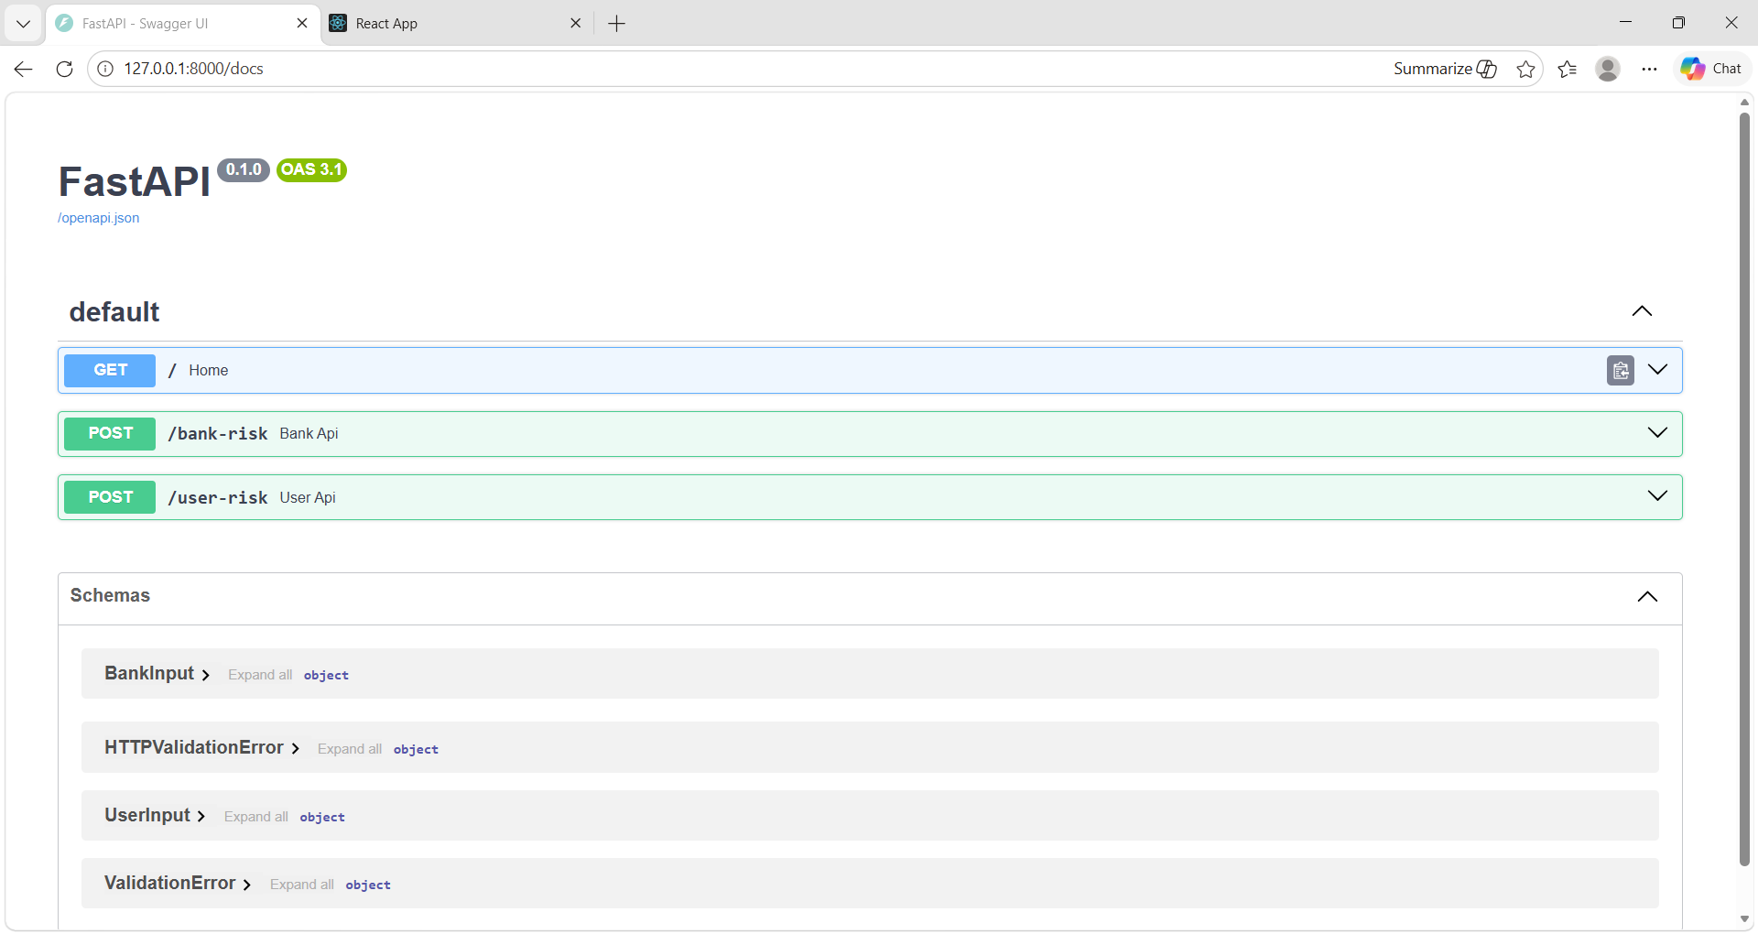
12
Bank Risk
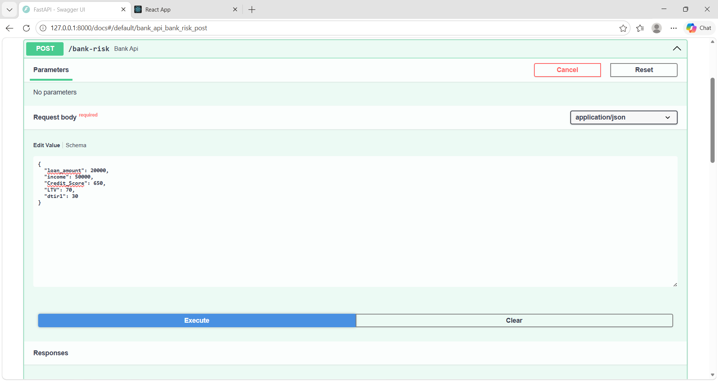

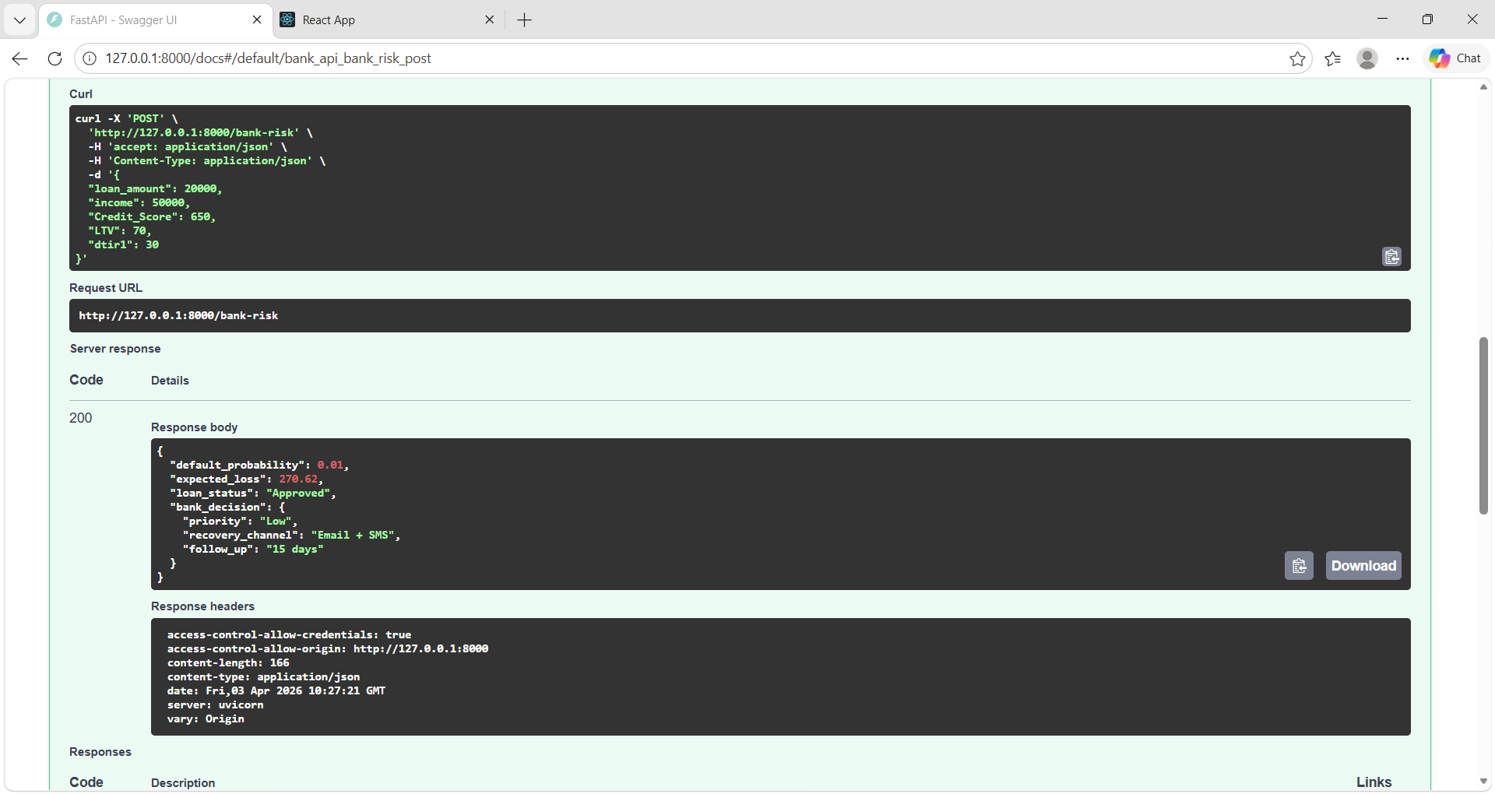

13
User risk
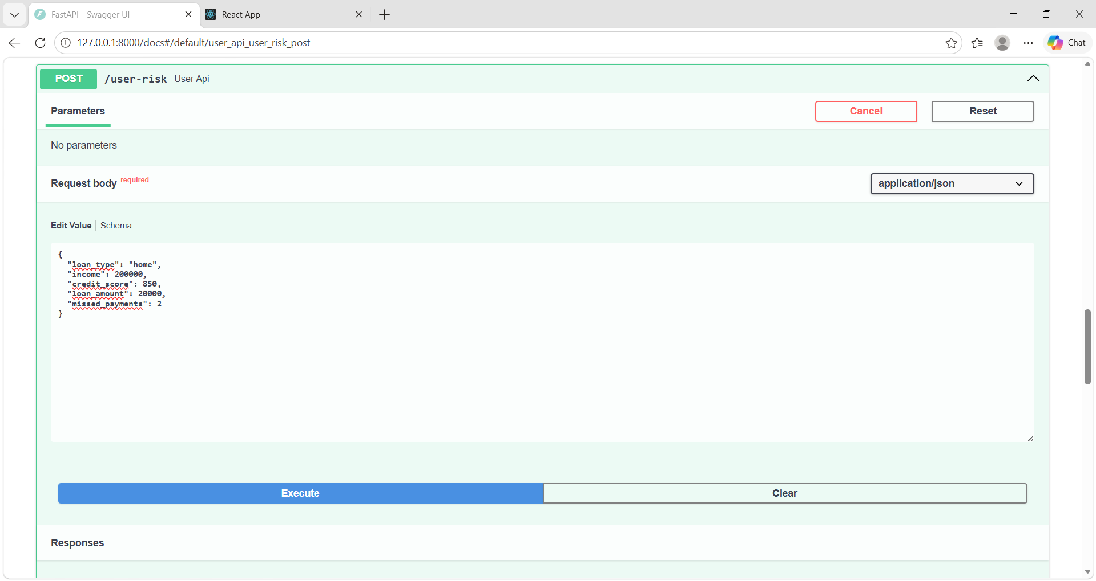

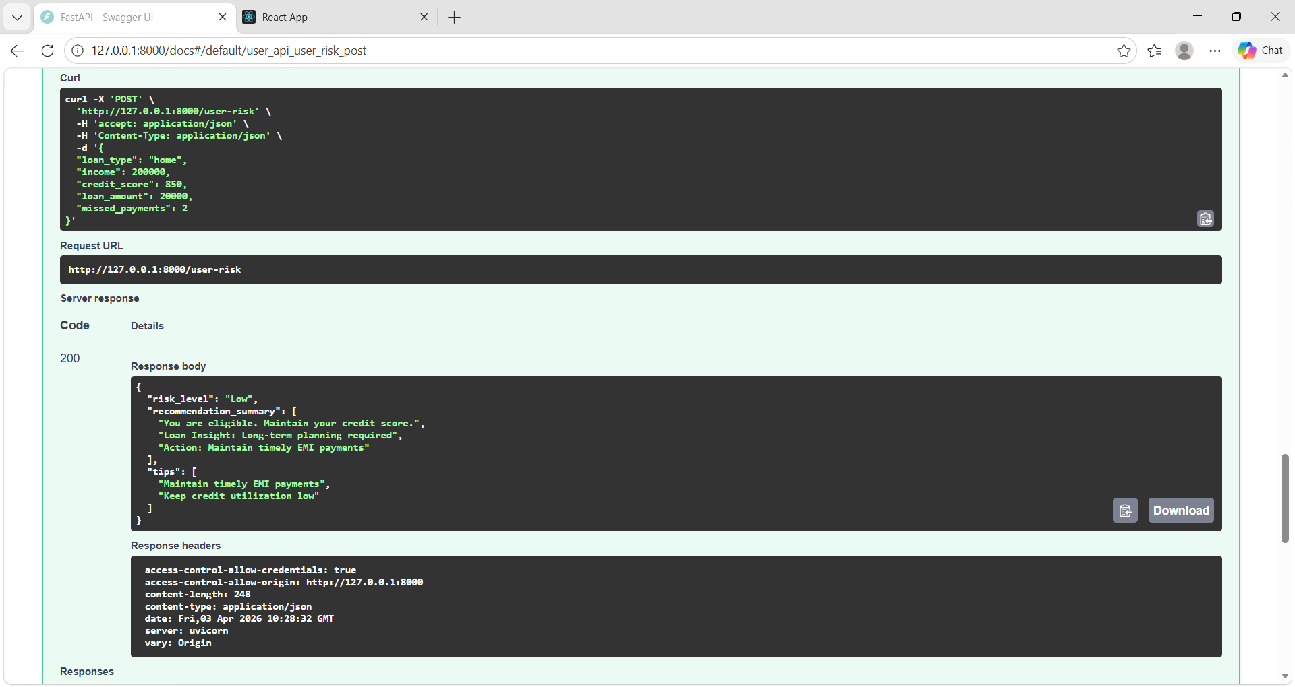

14
4.3 User Recommendation Engine
Logic
The user recommendation engine is designed to evaluate the financial condition of the borrower based on input parameters. It uses rule-based logic to analyze inputs such as credit score, income, loan amount, and repayment history. The logic determines the financial stability of the user and generates appropriate outputs.
Risk Classification
The system classifies users into three categories based on their credit score:
- Low Risk
- Medium Risk
- High Risk
This classification helps users understand their financial standing and their likelihood of loan approval. Each category is associated with specific recommendations and tips.
Example
For example, if a user has a high credit score and stable income, the system classifies them as low risk and suggests maintaining their financial habits. If the credit score is moderate, the system provides suggestions such as improving repayment behavior. In the case of low credit scores, the system advises users to reduce debt and avoid applying for loans until their financial condition improves.
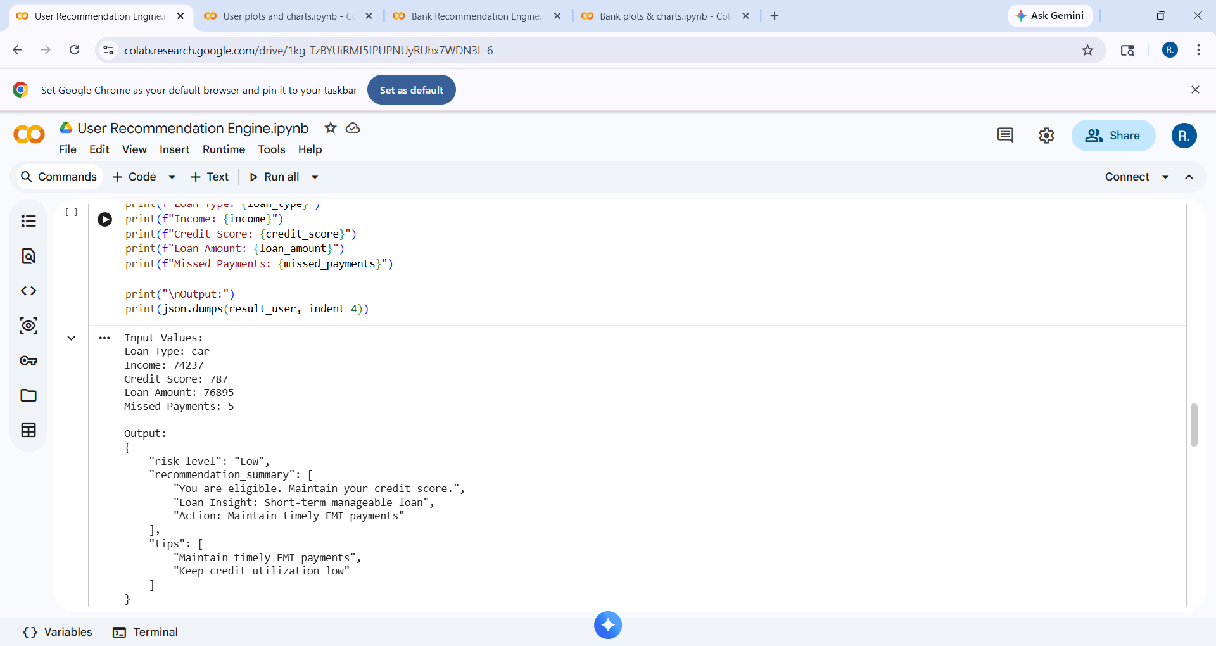
15
4.4 Bank Recommendation Engine
Default Probability
The bank recommendation engine calculates the probability that a borrower may default on a loan. This is determined using financial parameters such as credit score, income, loan amount, and financial ratios like LTV and DTI. The calculated probability helps banks understand the level of risk associated with the loan.

Decision Logic
Based on the calculated default probability, the system determines the loan status. If the risk is low, the loan is approved. If the risk is moderate, the loan is conditionally approved with certain precautions. If the risk is high, the loan is rejected. The system also provides decision strategies such as priority level and follow-up actions, helping banks manage risk effectively.
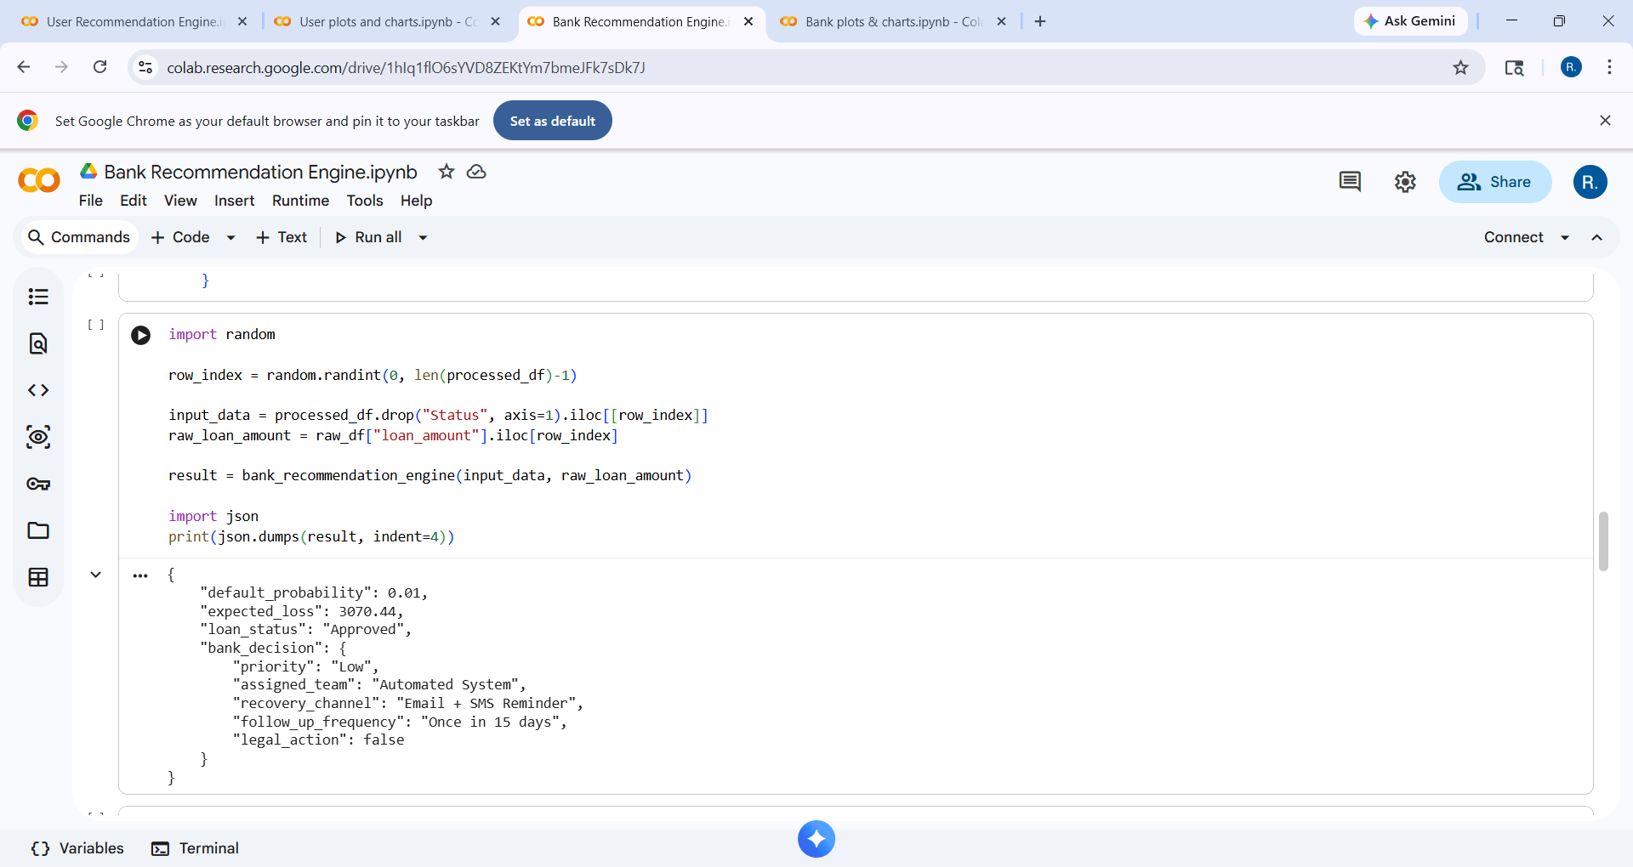

4.5 Frontend Implementation
Pages
The frontend is developed using React and consists of multiple pages such as Home, About, Contact, and Predict. Each page is designed to provide specific functionality and improve user interaction with the system.

16
Navigation
Navigation between pages is handled using routing, allowing users to move smoothly across different sections of the application. The navigation system ensures that users can easily access prediction features and other information.

API Integration
The frontend communicates with the backend using Axios. When a user submits input data, Axios sends a request to the backend API. The response received from the backend is then processed and displayed on the frontend.

Dynamic Rendering
The frontend dynamically updates the interface based on the results received from the backend. Predictions, recommendations, and charts are displayed instantly without requiring page reloads. This improves the responsiveness and usability of the system.

HOME PAGE:
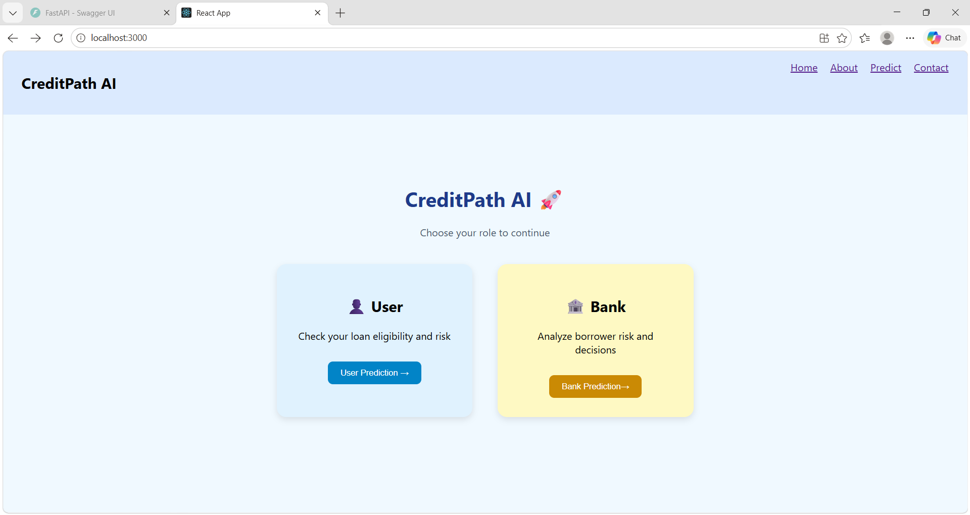

17
4.6 Charts & Visualization
User Charts
The system uses a pie chart to represent the distribution of the user’s credit score, helping visualize financial strength. A semi-circular chart is used to display the loan approval percentage, giving users an idea of their approval chances. A bar graph is used to compare financial parameters such as income and credit score, providing a clear overview of the user’s financial condition.
User Charts:
- Pie Chart → Credit distribution
- Semi-circle → Loan approval %
- Bar Chart → Financial overview
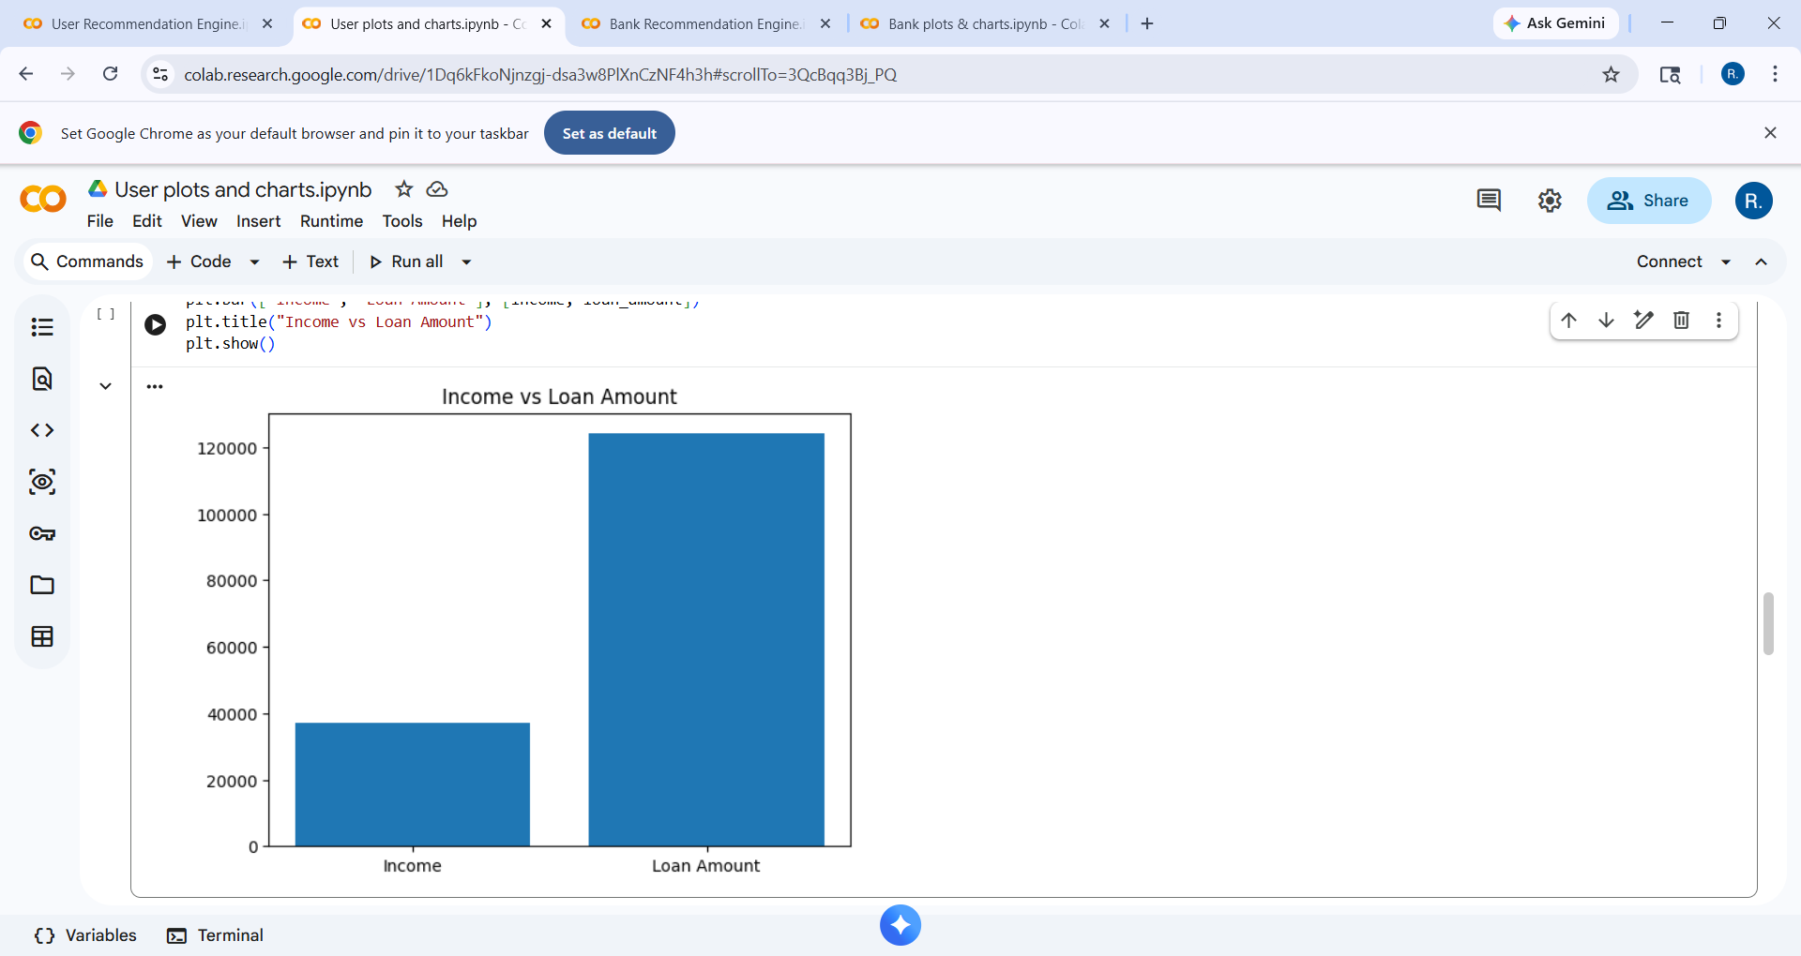
Bank Charts
For banks, bar graphs are used to represent risk metrics such as default probability and expected loss. A pie chart is used to show the distribution between risk and safe categories. These visualizations help banks quickly analyze borrower profiles and make decisions.
Bank Charts:
- Bar Graph → Risk analysis
- Pie Chart → Risk distribution
- Bar Graph → Decision metrics
18
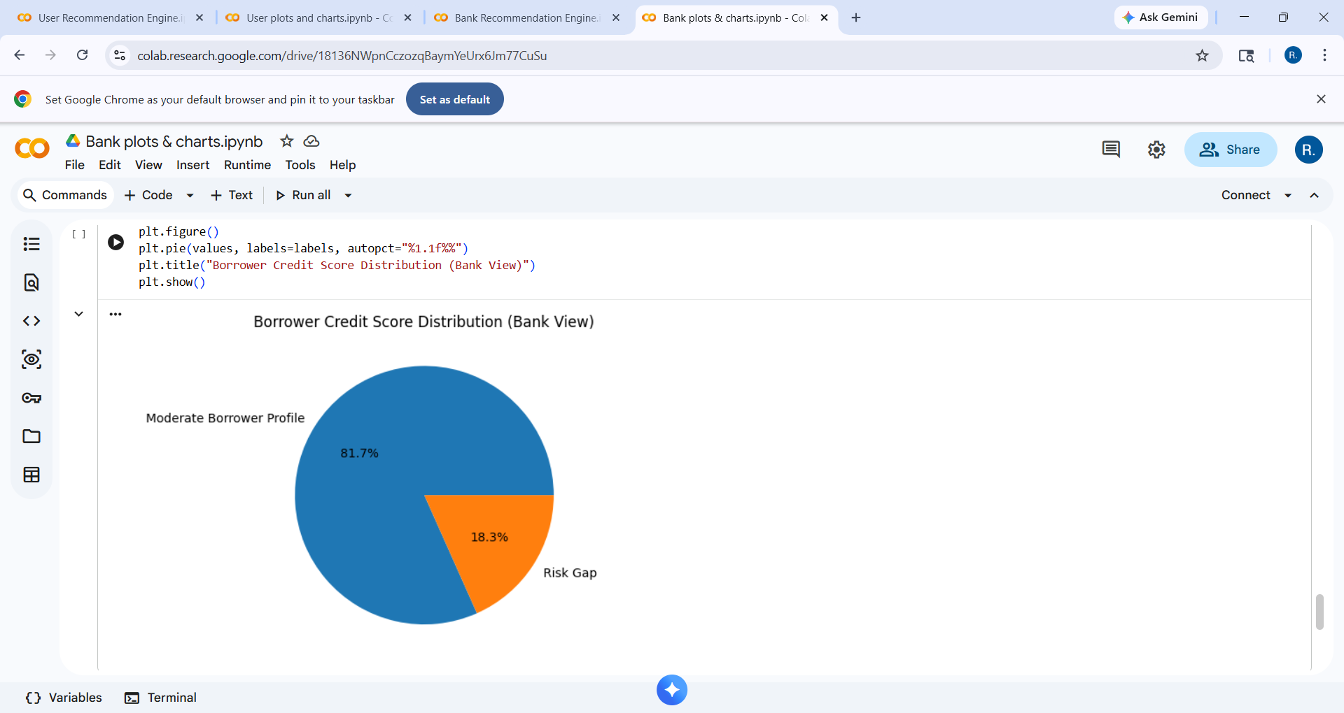

4.7 API Integration Flow
Axios Request
When the user submits input data, the frontend sends a request to the backend using Axios. The data is formatted into JSON and sent to the appropriate API endpoint.

Backend Response
The backend processes the request and returns the output in JSON format. This output includes risk levels, recommendations, and other relevant metrics.

Rendering
The frontend receives the response and dynamically displays the results. Charts and text outputs are rendered based on the received data, providing a complete view of the prediction.

19
RESULT
The CreditPath AI system successfully produces accurate and meaningful outputs for both users and banks. The results demonstrate the effectiveness of the system in predicting loan risk and providing actionable insights.
For users, the system classifies their financial condition into different risk levels such as low, medium, and high. Based on this classification, the system provides recommendations that help users improve their financial stability. For example, users with medium risk are advised to improve their credit score and reduce debt, while high-risk users are advised to avoid applying for loans until their financial condition improves.
For banks, the system calculates important metrics such as default probability and expected loss. These metrics help banks understand the level of risk associated with a loan. Based on the results, the system suggests whether the loan should be approved, conditionally approved, or rejected. This helps banks make informed decisions and reduce the chances of financial loss.
The visualization component enhances the understanding of results. Charts such as pie graphs and bar graphs provide a clear representation of risk distribution and financial metrics. This makes it easier for users and banks to interpret the results quickly.
The system performs efficiently and provides real-time responses. The predictions are consistent with the input data, and the recommendations are relevant and practical. The use of visualization improves user engagement and makes the system more intuitive.
User output
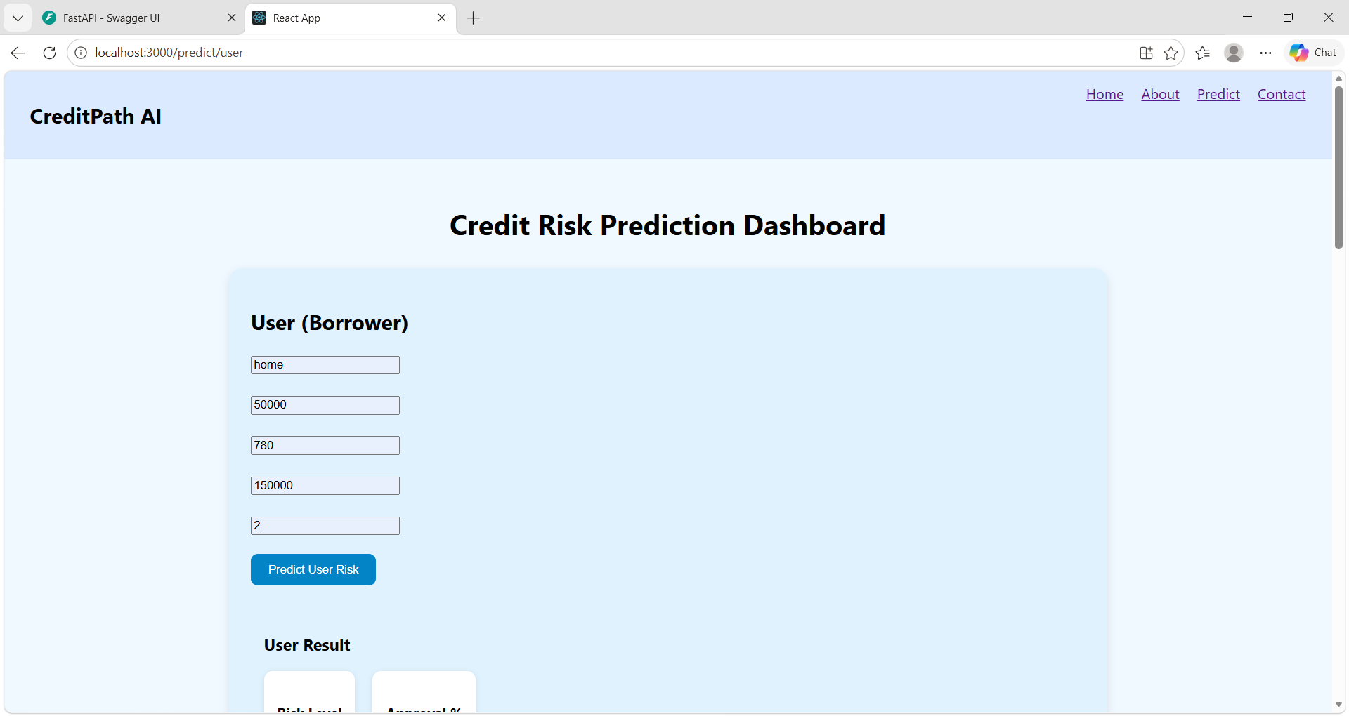
20
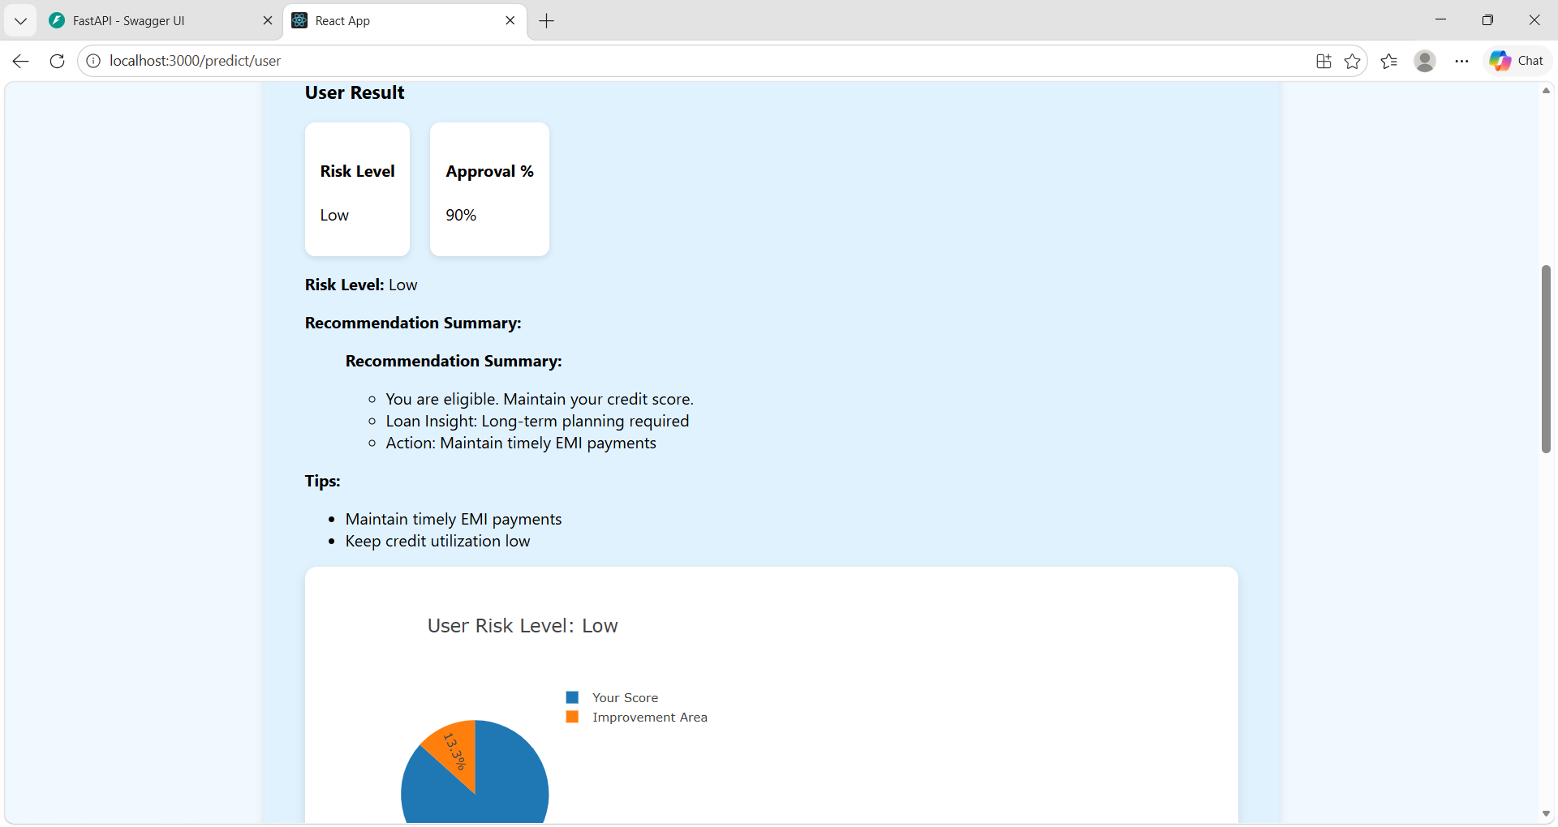

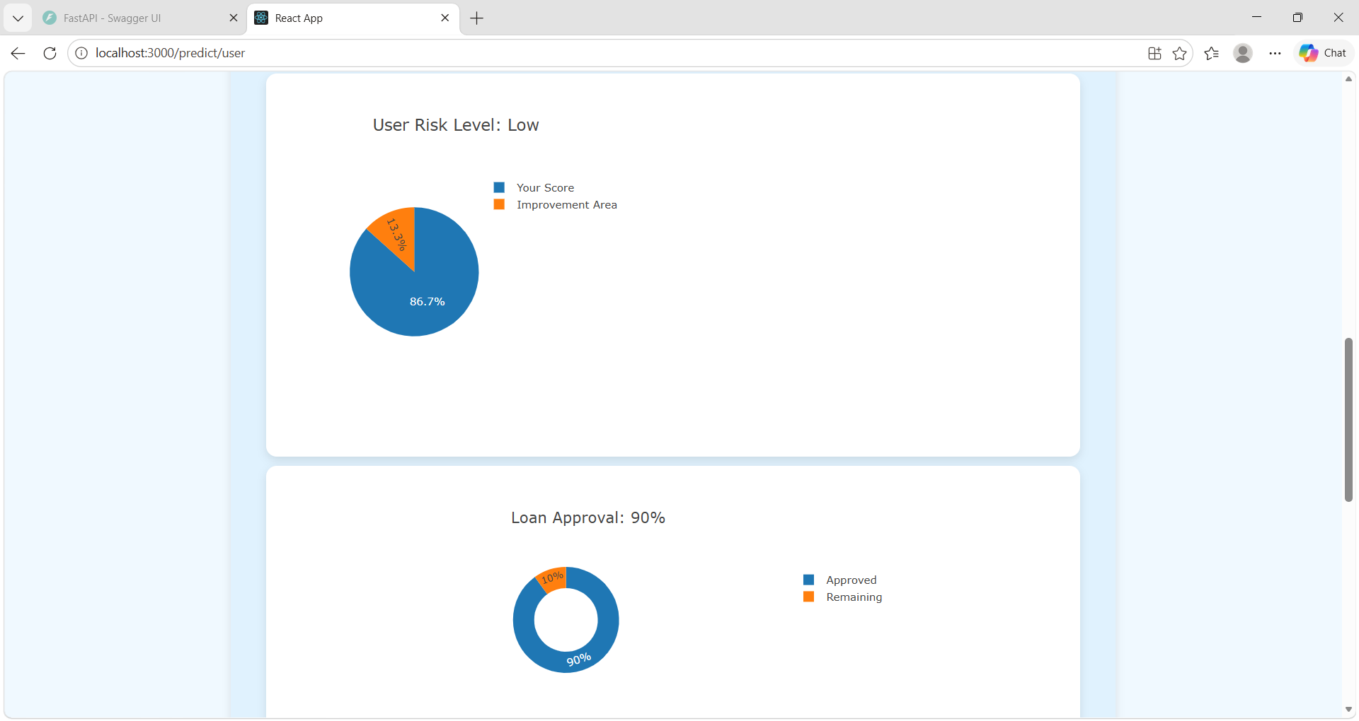

21
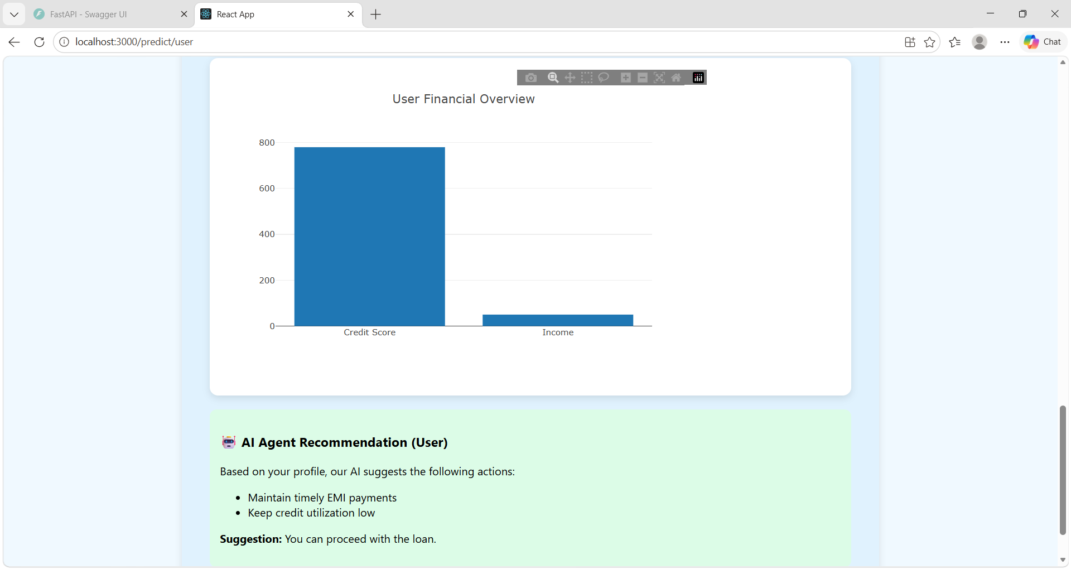

Bank output
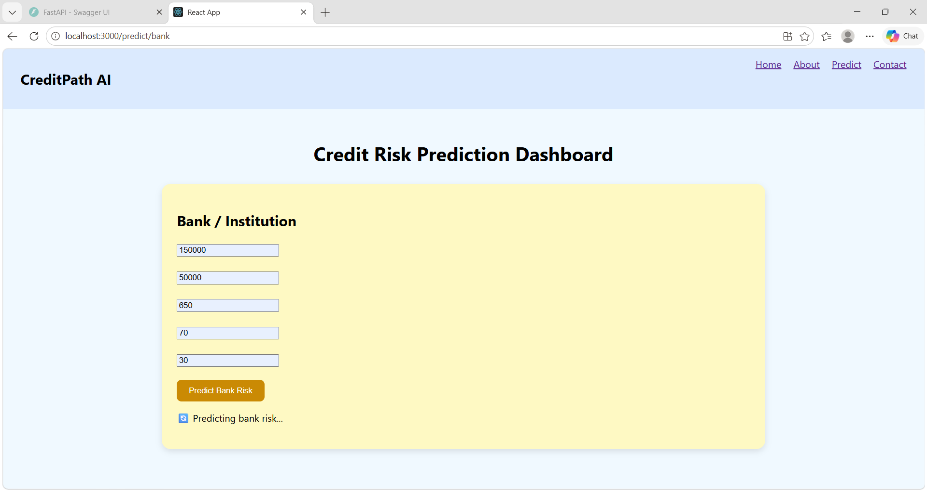

22
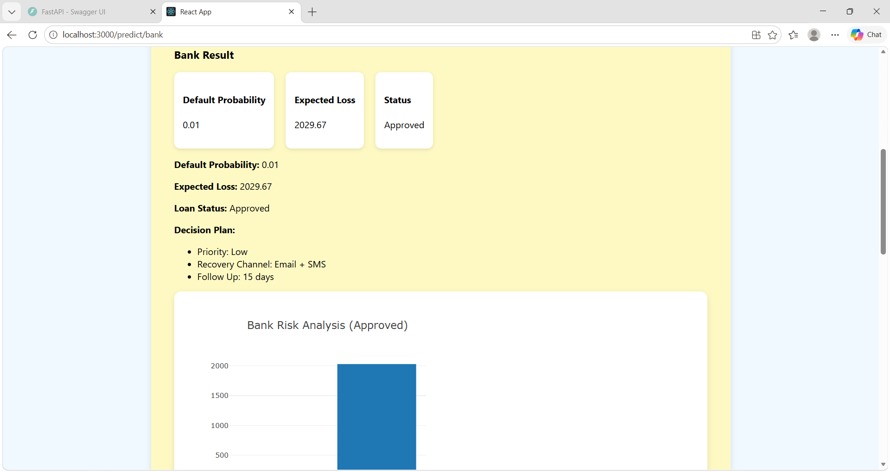

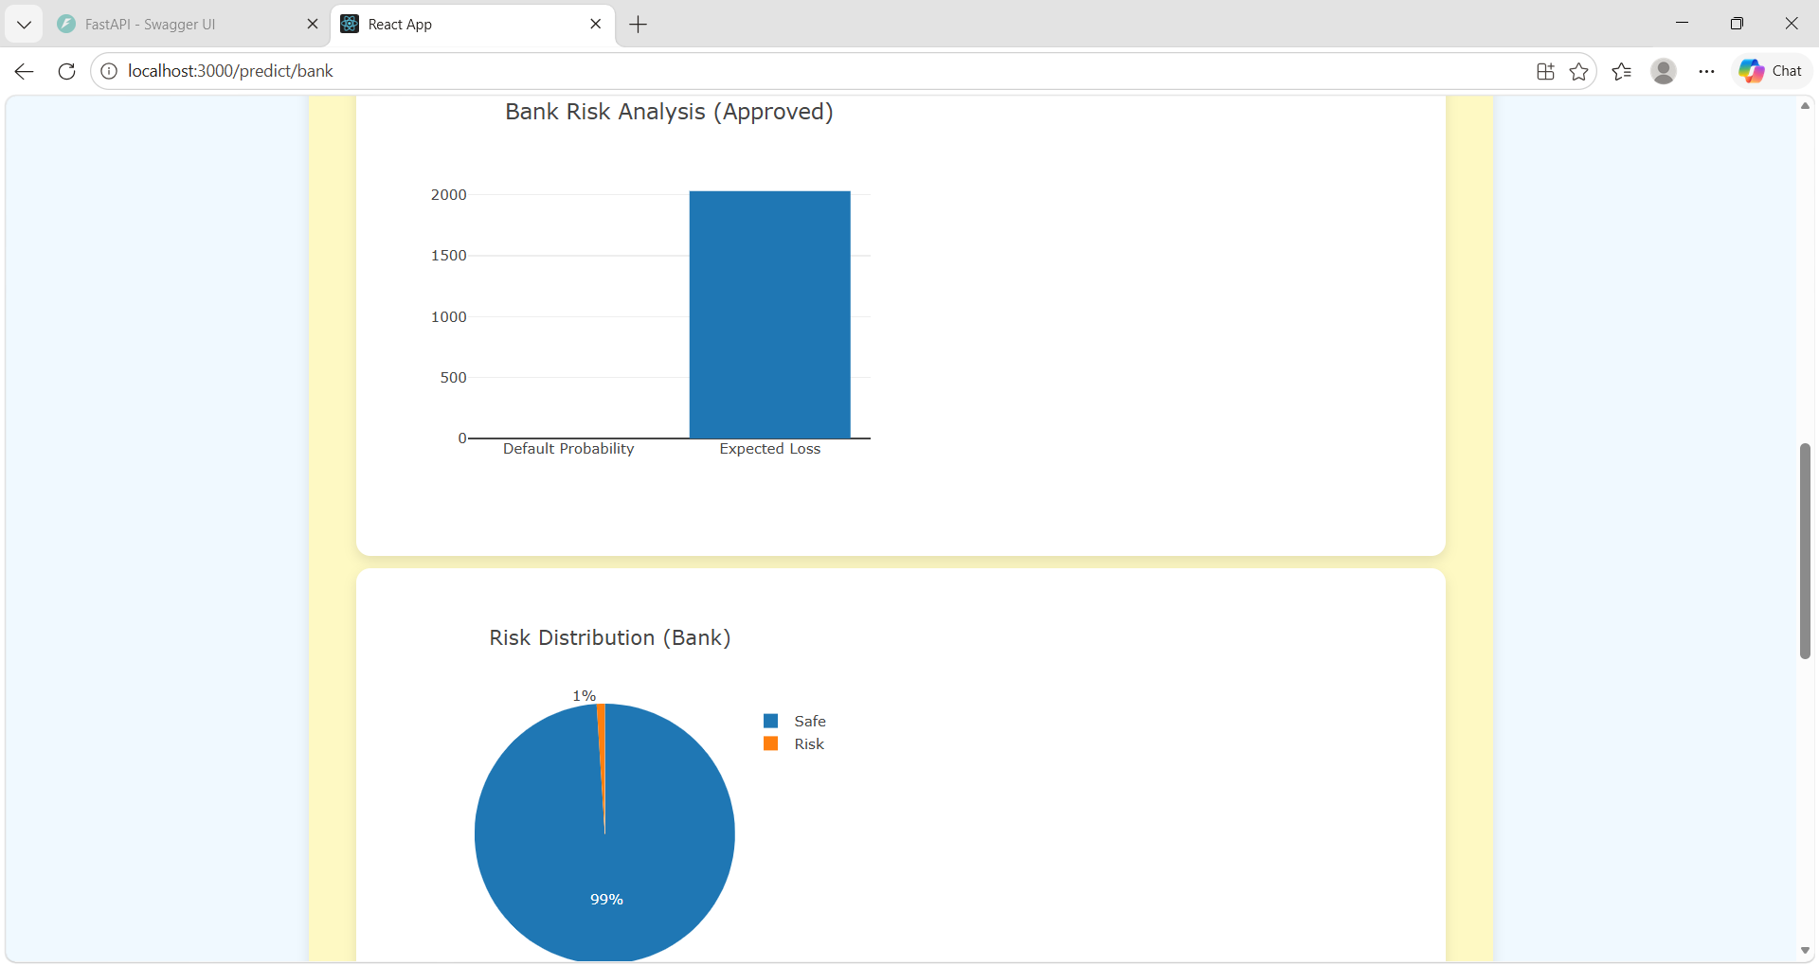

23
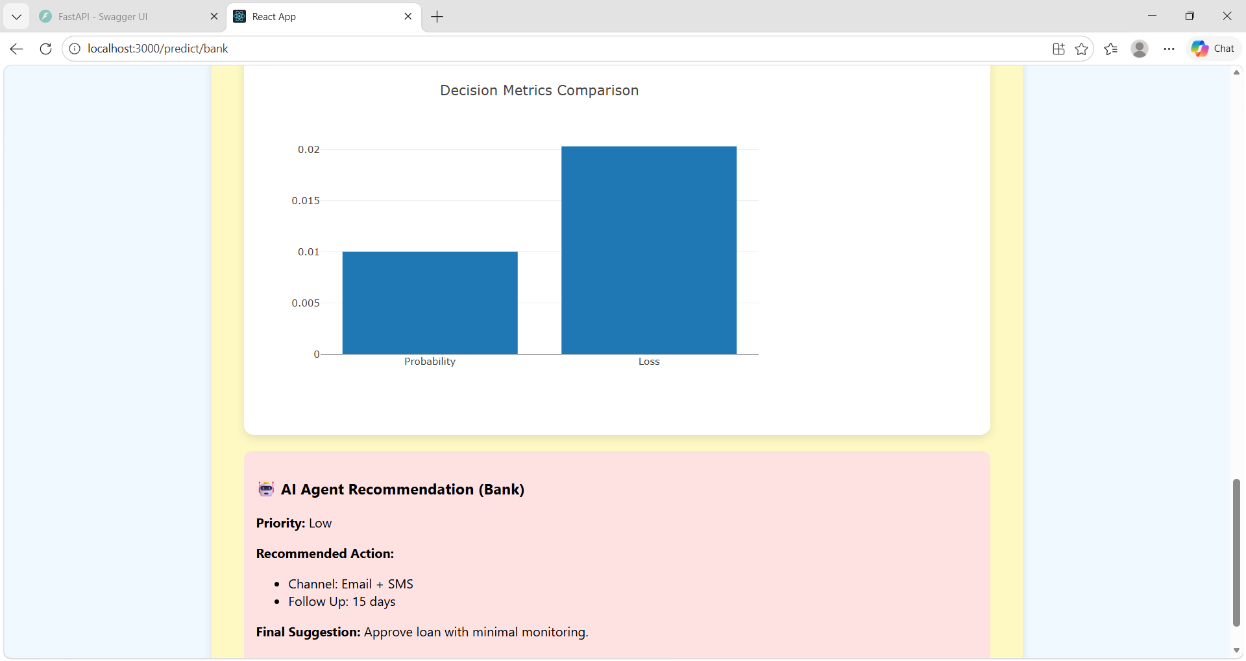

24
CONCLUSION
CreditPath AI successfully demonstrates the development of an intelligent and efficient loan risk prediction system. The project integrates backend processing, frontend visualization, and recommendation logic to provide a complete solution for financial decision-making.
The system achieves its objectives by accurately predicting risk levels, generating meaningful recommendations, and presenting results through interactive charts. It provides value to both users and banks by helping them understand financial risks and make informed decisions.
One of the major strengths of the system is its ability to combine prediction and visualization. While the prediction logic provides accurate results, the visualization component ensures that these results are easy to understand. This makes the system user-friendly and practical for real-world applications.
The project can be further enhanced by integrating advanced machine learning models and real-time financial data. Additional features such as user authentication, historical data analysis, and mobile application support can also be implemented.
In conclusion, CreditPath AI represents a significant step towards intelligent financial systems and demonstrates how technology can be used to improve decision-making in the banking sector.

